Tutorial – 4

- The employee list for a company contains employee code, name, designation and basic pay. The employee is given a house rent allowance (HRA) of 10% of the basic pay and dearness allowance (DA) of 45% of the basic pay. The total pay of the employee is calculated as Basic Pay + HRA + DA. Write a class to define the details of the employee. Write a constructor to assign the required initial values. Add a method to calculate HRA, DA and total pay and print them. Write another class with main method. Create objects for three different employees and calculate HRA, DA and total pay.

using System;
using System.Collections.Generic;
using System.Linq;
using System.Text;
using System.Threading.Tasks;

namespace _24SOECE13901_SAURAV_PANDIT_Tutorial_4
{
class Employee
{

public string EmpCode;
public string Name;
public string Designation;
public double BasicPay;
public double HRA;
public double DA;
public double TotalPay;

public Employee(string empCode, string name, string designation, double basicPay)
{
EmpCode = empCode;
Name = name;
Designation = designation;
BasicPay = basicPay;
}

// Method to calculate HRA, DA, and total pay
public void CalPay()
{
HRA = 0.10 * BasicPay; // HRA = 10% of basic pay

DA = 0.45 * BasicPay; // DA = 45% of basic pay
TotalPay = BasicPay + HRA + DA;

}

public void DisplayDetails()
{

Console.WriteLine("Employee Code: " + EmpCode);
Console.WriteLine("Name: " + Name);
Console.WriteLine("Designation: " + Designation);
Console.WriteLine("Basic Pay: " + BasicPay);
Console.WriteLine("HRA: " + HRA);
Console.WriteLine("DA: " + DA);
Console.WriteLine("Total Pay: " + TotalPay);
Console.WriteLine("-------------------------------");
}
}

internal class Q1
{
static void Main(string[] args)
{
// Creating objects for three employees

Employee emp1 = new Employee("E001", "Mohin", "Manager", 50000);
Employee emp2 = new Employee("E002", "Rahul", "Developer", 40000);
Employee emp3 = new Employee("E003", "Saurav", "Analyst", 35000);

// Calculate pay and display details
emp1.CalPay();
emp1.DisplayDetails();

emp2.CalPay();
emp2.DisplayDetails();

emp3.CalPay();
emp3.DisplayDetails();
}
}
}

Output:
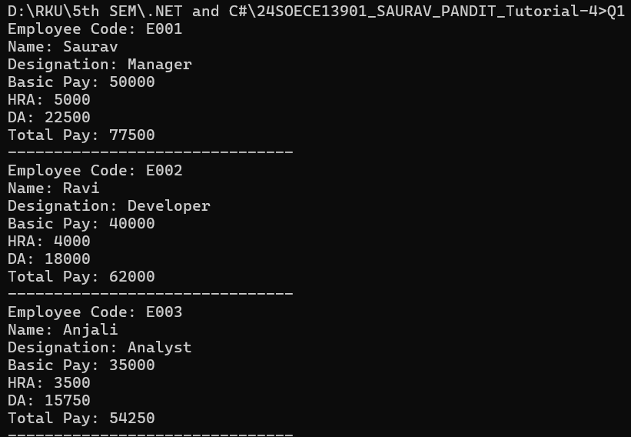

- From the following code and given output, complete missing statements and find out error code and correct it.
using System;
using System.Collections.Generic;
using System.Linq;
using System.Text;
using System.Threading.Tasks;

namespace _24SOECE13901_SAURAV_PANDIT_Tutorial_4
{
// Base class
class Shape
{
public double Width;
public double Height;

public void ShowDim()

{
Console.WriteLine("Width and height are " + Width + " and " + Height);
}
}

// Derived class
class Triangle : Shape
{
public string Style; // style of triangle

// Return area of triangle
public double Area() // << Missing statement-1: return type and method signature
{
return Width * Height / 2;
}

// Display a triangle's style
public void ShowStyle() // << Missing statement-2: display Style
{
Console.WriteLine("Triangle is " + Style);
}
}

internal class Q2
{
static void Main()
{
// Correct object creation
Triangle t1 = new Triangle();
Triangle t2 = new Triangle();

// Assign values to t1
t1.Width = 4.0;
t1.Height = 4.0;
t1.Style = "isosceles";

// Assign values to t2
t2.Width = 8.0;
t2.Height = 12.0;
t2.Style = "right";

// Display info for t1

Console.WriteLine("Info for t1: ");
t1.ShowStyle();
t1.ShowDim();
Console.WriteLine("Area is " + t1.Area());

Console.WriteLine();

// Display info for t2
Console.WriteLine("Info for t2: ");
t2.ShowStyle();
t2.ShowDim();
Console.WriteLine("Area is " + t2.Area());
}
}
}

Output:
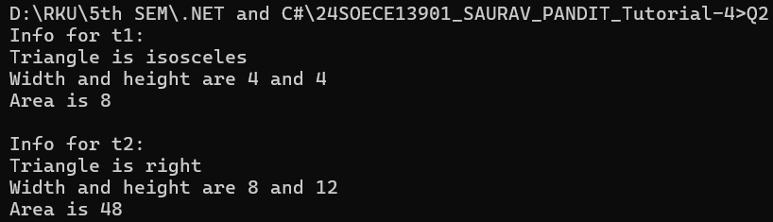

- Draw a real picture for single level inheritance.
Perform following tasks.
Task 1: Create a class
Task 2: Add few data members as private, protected and public
Task 3: Add few methods as public to work on defined data members
Task 4: Create another applicable class which inherits members from above class
Task 5: Add few data members as private, protected and public into second class
Task 6: Add few methods as public to work on defined data members into second class
Task 7: Create a Demo class with main method.
Task 8: Create at least two objects of a second class defined in Task 4 into main method and call all methods using that object.
Task 9: Write comment for each important portion of code like data members’ declaration, methods, some important logic etc.
Task 10: Summarize above solution in your own few words to visualize the solution to the end user.

using System;
using System.Collections.Generic;
using System.Linq;
using System.Text;
using System.Threading.Tasks;

namespace _24SOECE13901_SAURAV_PANDIT_Tutorial_4
{
// Task 1: Create a class
class Person
{

// Task 2: Add data members with different access specifiers
private int id;
protected int age;
public string name;

// Task 3: Public methods to work with data members
public void SetDetails(int id, int age, string name)
{
this.id = id;
this.age = age;
this.name = name;
}

public void ShowDetails()
{
Console.WriteLine("Person Details:");
Console.WriteLine("ID:" + id + ", Age:" + age + ", Name: " + name);
}
}

// Task 4: Create another class inheriting Person
class employee : Person
{

// Task 5: Add data members with different access specifiers
private string empCode;
protected string department;
public double salary;

// Task 6: Public methods to work with data members
public void SetempDetails(string empCode, string department, double salary)
{
this.empCode = empCode;
this.department = department;
this.salary = salary;
}

public void ShowempDetails()
{
Console.WriteLine("Employee Details:");
Console.WriteLine("Name" + name + ", Age:" + age + ", EmpCode: " + empCode + ", Department:" + department + ", Salary: " + salary);
}
}

internal class Q3
{

static void Main()
{
// Task 8: Create two objects of Employee
employee e1 = new employee();
employee e2 = new employee();

e1.SetDetails(101, 25, "Saurav");
e1.SetempDetails("E001", "IT", 50000);
e1.ShowDetails();
e1.ShowempDetails();

Console.WriteLine();

e2.SetDetails(102, 30, "Haresh");
e2.SetempDetails("E002", "HR", 60000);
e2.ShowDetails();
e2.ShowempDetails();
}
}
}

Output:
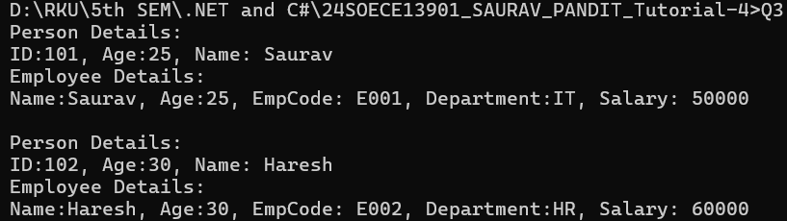

- From the following code and given output complete missing statements and find out error code and correct it.
using System;
using System.Collections.Generic;
using System.Linq;
using System.Text;
using System.Threading.Tasks;

namespace _24SOECE13901_SAURAV_PANDIT_Tutorial_4
{
class StaticVar
{
public static int num; // static variable

// Constructor (increments num each time object is created)
public StaticVar()
{
num++;
}

// Missing statement: static method to return num
public static int getNum()
{
return num;
}
}

internal class Q4
{
static void Main(string[] args)
{

// Creating 3 objects (each constructor call increments num)
new StaticVar();
new StaticVar();
new StaticVar();

Console.WriteLine("Variable num: {0}", StaticVar.getNum());

Console.ReadKey();
}
}
}

Output:

- Find out error code and correct it. Print appropriate output as desired.

using System;
using System.Collections.Generic;
using System.Linq;
using System.Text;
using System.Threading.Tasks;

namespace _24SOECE13901_SAURAV_PANDIT_Tutorial_4
{
public class A // Base class
{
public A(int value)
{
// Executes some code in the constructor
Console.WriteLine("Base constructor A()");
}
}

public class B : A // Derived class
{
public B(int value) : base(value)
{
// Base constructor is called first
// Then this code is executed
Console.WriteLine("Derived constructor B()");

}
}
internal class Q5
{
static void Main()
{
// Create base class object
A a = new A(0);

// Create derived class object
B b = new B(1);
}
}
}

Output:
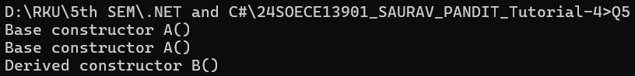

- Find out error code and correct it. Print appropriate output as desired.

using System;
using System.Collections.Generic;
using System.Linq;
using System.Text;
using System.Threading.Tasks;

namespace _24SOECE13901_SAURAV_PANDIT_Tutorial_4
{
abstract class Test
{
protected int a; // protected so derived classes can access it

public abstract void A(); // must have access modifier
}

class Example1 : Test
{
public override void A()
{

Console.WriteLine("Example1.A");
a++;
Console.WriteLine("a = " + a);
}
}

class Example2 : Test
{
public override void A()
{
Console.WriteLine("Example2.A");
a--;
Console.WriteLine("a = " + a);
}
}
internal class Q6
{
static void Main()
{
Test test1 = new Example1();
test1.A();

Test test2 = new Example2();
test2.A();
}
}
}

Output:
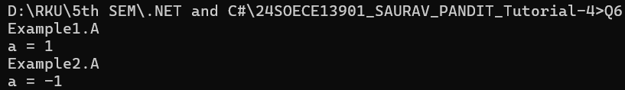

- Refer given output and find out error code and correct it.

using System;
using System.Collections.Generic;
using System.Linq;
using System.Text;
using System.Threading.Tasks;

namespace _24SOECE13901_SAURAV_PANDIT_Tutorial_4
{

sealed class AB
{
public int x;
public int y;
}
internal class Q7
{
static void Main()
{
AB sc = new AB();
sc.x = 110;
sc.y = 150;

Console.WriteLine("x = {0}, y = {1}", sc.x, sc.y);
}
}
}

Output:

- This program will throw an exception. Add try, catch and finally blocks to handle this exception.

using System;
using System.Collections.Generic;
using System.Linq;
using System.Text;
using System.Threading.Tasks;

namespace _24SOECE13901_SAURAV_PANDIT_Tutorial_4
{
internal class Q9
{
public static void Main()
{
int x = 0;
int div = 0;

try
{
div = 100 / x;
Console.WriteLine("Result: " + div);
}
catch (DivideByZeroException ex)
{
Console.WriteLine("Error: Cannot divide by zero.");
Console.WriteLine("Exception details: " + ex.Message);
}
finally
{
Console.WriteLine("Program execution completed (finally block executed).");
}
}
}
}

Output:
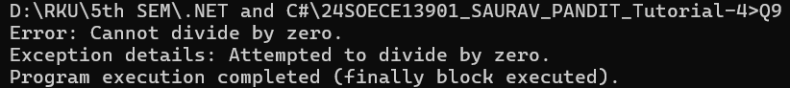

- Arrange the code to get desirable output

using System;
using System.Collections.Generic;
using System.Linq;
using System.Text;
using System.Threading.Tasks;

namespace _24SOECE13901_SAURAV_PANDIT_Tutorial_4
{
class MyException : Exception
{
// Constructor that accepts a string message
public MyException(string message) : base(message)
{
}
}

internal class Q10
{
public static void Main()
{
try
{
throw new MyException("my exception generated.");
}
catch (Exception e)
{
Console.WriteLine("Exception caught here: " + e.Message);
}
Console.WriteLine("LAST STATEMENT");
}
}
}

Output:

